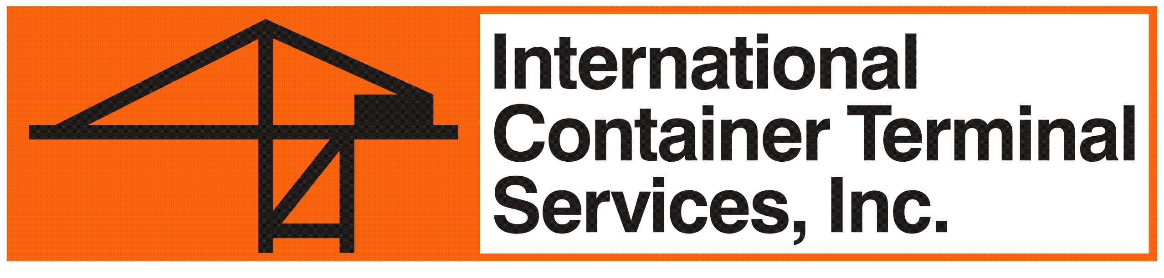
APPLICATION FOR SUB CO-LOADER

(Shipping Line) appoints (Sub Co-loader) as our official Sub co-loader on (Vessel Operator) vessel calling MICT under (Service Name) service. Terminal Services invoicing will be as follows:

a. Vessel Charges b. Export-Import Storage Charges;
Shut-Out Charges;
Hazardous Cargo Charges;
Reefer Electrical Charges;
Empty Handling Fees;
____ Line’s Account ____ Line’s Account

____ Sub Co-loader’s Account ____ Sub Co-loader’s Account

(Shipping Line) agrees and guarantees to pay in full any unsettled account of our designated sub co-loader in case our sub co-loader fails to pay any and all invoices due to ICTSI-MICT and undertakes to observe the conditions under the Co-Loading Guidelines. For co-loading details, it is undertaken that there will be no manual modification of any EDI or loading data that is duly received and accepted by ICTSIMICT and the details and identity of the containers duly received shall be taken as is. This application as well as the parties herein are subject to the provisions of the Standard Trading Conditions(STC) of MICT, a copy of which is available upon request and can be viewed at www.mict.com.ph/terms-conditions.

APPLICANT

____________________________________________
(Name)
(Title), (Shipping Line)

SUB CO-LOADER

___________________________________________
(Name)
(Title), (Sub Co-loader)

VESSEL OPERATOR

___________________________________________
(Name)
(Title), (Vessel Operator)

APPROVER

Santiago T. Fuentes III
MICT Terminal Operation Head
Date: ________________

